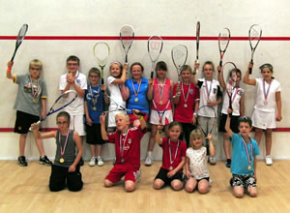
Hoppers Squash section is running a programme of Sunday morning squash and racquetball training for 5 to 16 year olds. This is perfect to complement the Sunday mini-rugby and ideal for those children, both girls and boys, who want fitness and fun but don’t want to play rugby.
Mini Squash is the England Squash & Racketball’s fun and exciting version of squash for 5-11 year olds. Children as young as 5 years old can learn to throw, catch and hit a ball. It’s not just about squash, it’s about movement co-ordination & balance. If you can show children from a young age the principles of movement, co-ordination & balance then they will take this into every sport they play and give them loads of confidence in addition to fitness and mobility.
Very quickly children can play modified versions of squash in a fun environment.
The mini Squash Program is a skills based program where the emphasis is more on skills than on competition and winning matches. They chart their progress through passing skills tests and gaining Mini Squash Certificates..
The junior training sessions are for older children who can co-ordinate ball striking and are keen to develop their squash and play more than once a week. The age range of the juniors can be from 8-16. Junior sessions are planned to develop fitness, movement, technique and tactics. They are fun and more competitive.
Mini and junior Sunday sessions are great for health, fitness and co-ordination but keen juniors can join the squash club and play more regularly supported by our superb coach Mike Farrington.
Sessions run concurrently with mini-rugby from 10am to 12.30pm every Sunday and all equipment is provided by the club except for clothing and non-marking footwear. For further information see our stand at the mini-rugby enrolment or contact Gary Jackson on 07775-753968 or Bob Lonsdale on 07764-211136.
 | Price per ten-week term * | £25
 | Price for year (Two ten-week terms)* | £45
*Cheques payable to Preston Grasshoppers R.F.C.
Enrolment Form
Enrolment Form
Parents Name …………………………………………………………………………………………………..
Address ……………………………………………………………………………………………..
Postcode ………………………………
Name of child ……………………………………………….
Age ………………………………
Additional child ……………………………………………….
Age ………………………………
Total Amount Paid ………………………………..
Cheque Number …………………………………..

